Quick Snacks

*Design Document*

|  |  |  |
| --- | --- | --- |
| **Supervisor.** | **Sir Sameer Faisal** | |
| **Batch.** | **2212C2** | |
| **Group.** | **A** | |
| **Serial No.** | **Enrollment Number** | **Student Name** |
| 1. | 1445169 | Ahtesham |
| 2. | 1428847 | Umme Fatima |
| 3. | 1443726 | Rabia Malik |
| 4. | 1446623 | Abdullah |

**ACKNOWLEDGEMENT**

To start with we would like to thank each other for always being cooperative, we would also like to thank our teacher for always being available and guiding us through this journey.

We are also very thankful to the E-Project team at Aptech Head Office, who gave us this golden opportunity to display this project.

Lastly, we would like to thank the E-Project team due to them we were able to learn more such as:

This project allowed us to brush up on our skills. we were provided with a mentor to ensure that we do not drift from our project and to guide us through. This opportunity gives us the luxury of giving professional interviews easily as we have to explain and present it to the higher-ups.

***SYNOPSIS***

Welcome to "Quick Snacks" – your ultimate destination for exploring a wide variety of delectable snacks that are perfect for those on-the-go moments. Our website is a one-stop platform that offers comprehensive information about different types of snacks, caters to your snacking needs, and provides a seamless shopping experience.

***PROBLEM DEFINITION***

Even though snacking has developed a "bad image," snacks can be an important part of your diet. They can provide energy in the middle of the day or when you exercise. A healthy snack between meals can also decrease your hunger and keep you from overeating at meal time.

We are looking forward to develop a website “QuickSnacks” which will include quick snacks recipes

The website which they demand is suppose to provide user friendly environment and navigation. The important menu must be stated in the top section of the webpage. Also a decent look out and color combination is expected.

The website is to be developed for the Windows Platform using HTML5, JavaScript and Geolocation. The site should work well in all leading browsers including Chrome, IE, Firefox etc.

***CUSTOMER REQUIREMENT***

***SPECIFICATION (CRS)***

1. Home page with suitable images /offers should be provided. Navigation links must be included
2. The user should be able to browse through various categories
   1. Healthy Snacks
   2. Snacks for kids
   3. Easy on stomach snacks
   4. Smoothies

User can add more related categories if wish to.

1. When user selects any of the category, the various items should be listed and further if user selects any particular item , details of that item should be displayed. Details should include
   1. Ingredients along with proportion
   2. Detailed recipe
   3. Estimated time taken to prepare
   4. Approx quantity ( e.g. : can serve 2, can serve 4 and so on)
   5. Calorie and related information
2. Site should include reviews/feedbacks section on various snacks
3. There should be a separate section providing information on certain items needed for particular snacks as where it can be best purchased.
4. Gallery should be available which will showcase the small celebration videos/images
5. Contact us page: contact us details with location should be displayed using GeoLocation API (eg. GoogleMaps).
6. Also each link must be properly hyperlinked, images must be used wherever necessary.

***SCOPE OF THE WORK***

The scope of your website, "Quick Snacks Hub," includes offering a wide range of snack information, categorized menus, user accounts for personalization, e-commerce capabilities for purchasing snacks, a community forum for engagement, showcasing snack trends and reviews, mobile responsiveness, effective search and filtering, marketing strategies, and potential future expansions like tutorials and collaborations. The website aims to create a comprehensive and interactive space for snack enthusiasts to explore, shop, engage, and stay updated on the latest snack trends.

***AGGREGATED SITEMAP***

login

home

gallery

Feedbackkyyyyyyyyyyyyyyyyyy

About us

Categoryyyyyyyyyyyyyyyyyyyy

Menu

Contact us

Sign up

***SITEMAP ENGLISH***



***WIREFRAMES***

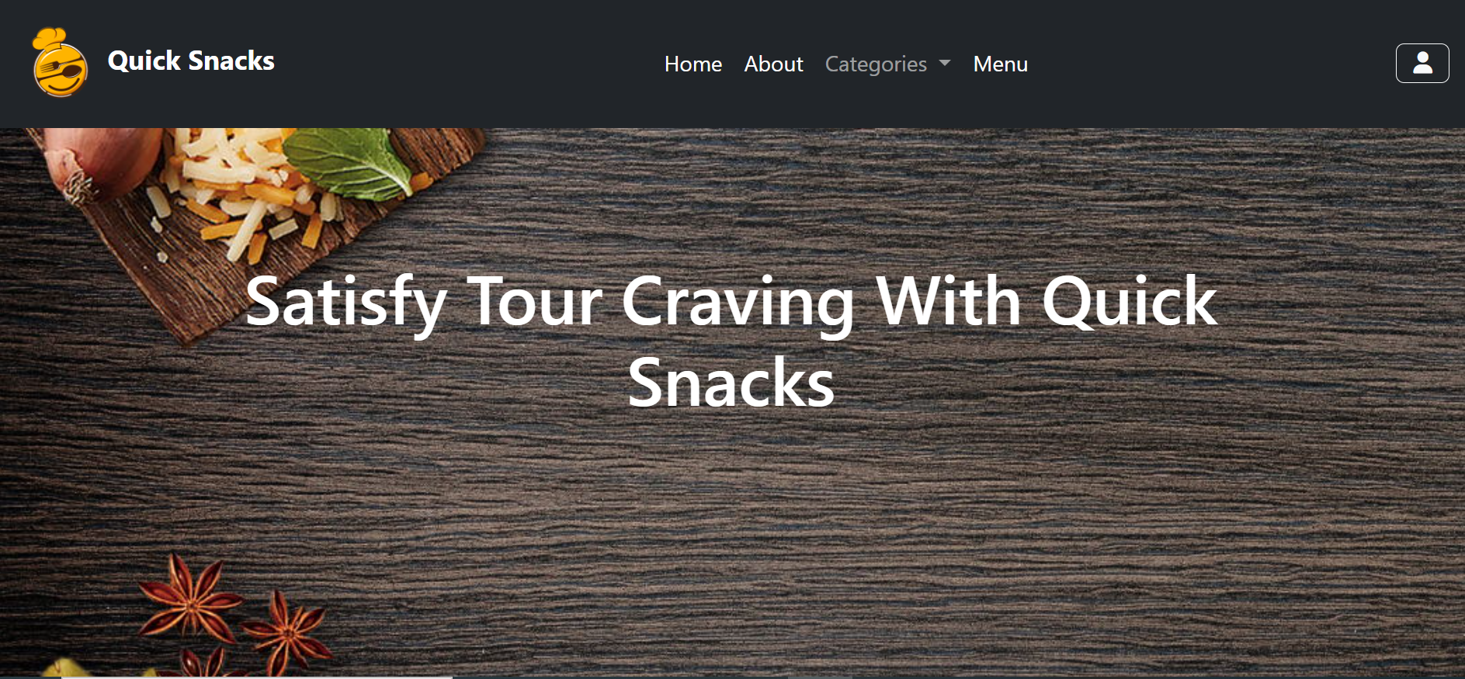

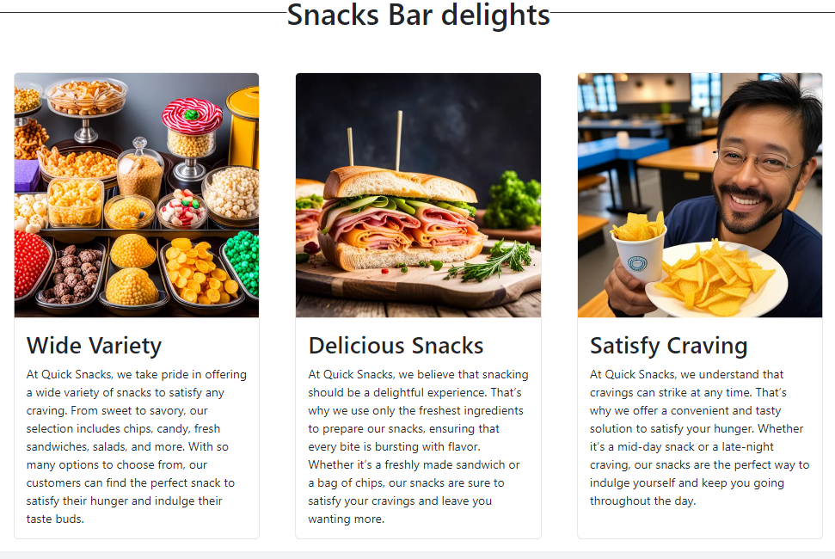

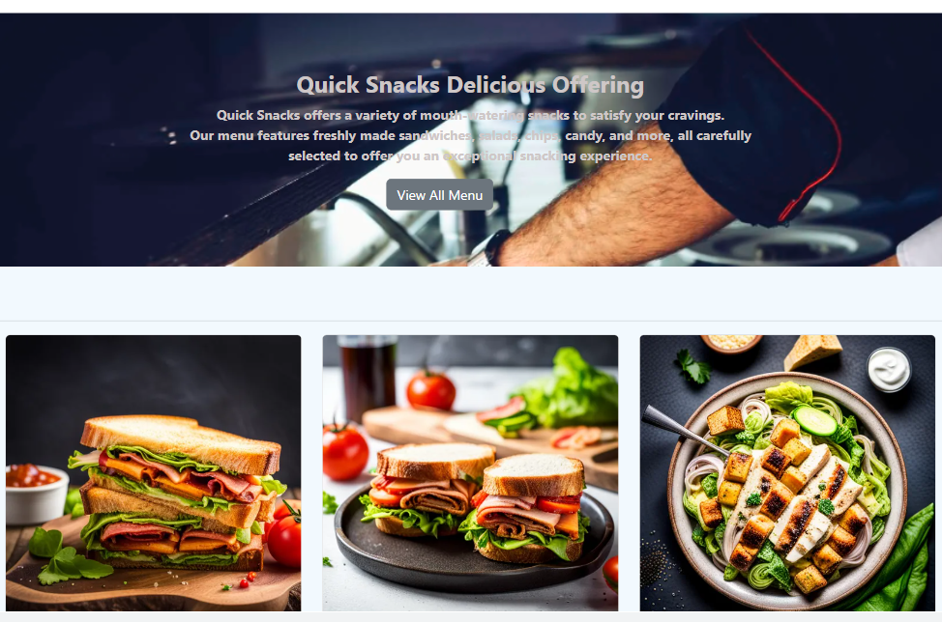

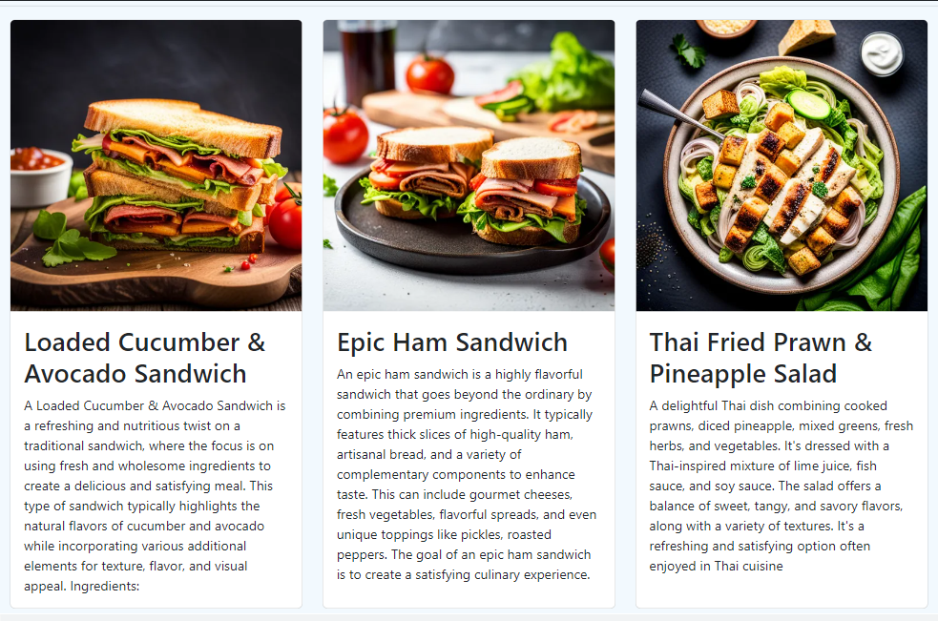

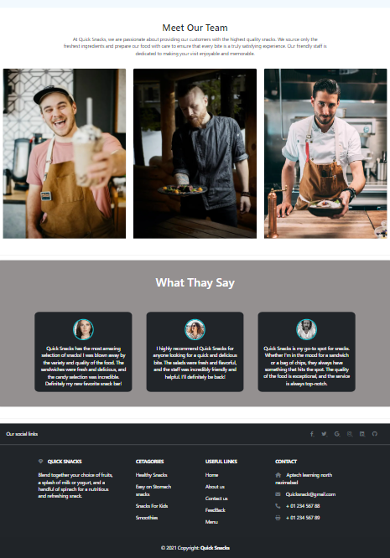

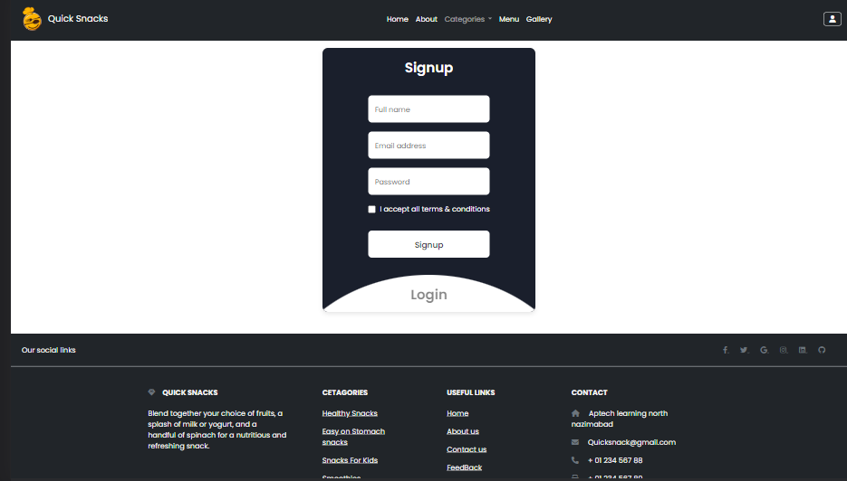

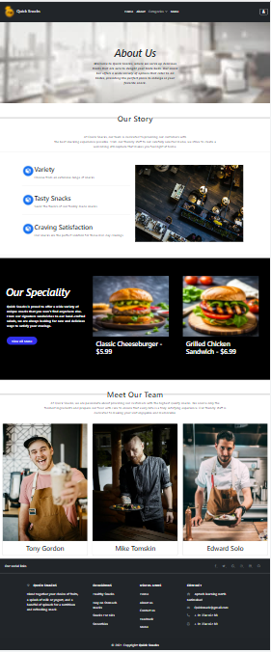

***TASK SHEET REVIEW 2***

|  |  |  |  |  |  |  |
| --- | --- | --- | --- | --- | --- | --- |
| Project Ref. No.: eP/Advertisement Portal Management System/01 | | Project  title | Date of Preparation of Activity Plan | | | |
| No | Task | Quick snacks | Actual | Actual | Team-mate | Status |
| Start Date | Days | Names |
| 1. | Build Home, Visit Page | 22/aug/23 | 1 | Ahtesham  &  abdullah | Complete |
| 2. | Build  Gallery page | 29/aug/23  8/mar/23 | 1 | Abdullah  &  ahtesham | Complete |
| 3. | Build About us page | 25/aug/23 | 2 | Ahtesham  &  Fatima | Complete |
| 4. | Build login and Signup Page | 26/a  Aug/23 | 1 | Ahtesham | Complete |
| 5. | Found pictures | 27/Aug/23 | - | Rabia  &  fatima | Complete |
| 6. | Build contact page | 29/Aug/23 | 1 | Ahtesham  &  Abdullah | Complete |
| 7. | Beginning javascript code for signup and login page,home | 30/Aug/23 | 1 | ahtesham | Complete |

|  |  |  |  |  |  |  |
| --- | --- | --- | --- | --- | --- | --- |
| 8. | Beginning code for the homepage |  | 23/Aug/23 | 1 | Ahtesham  &  Abdullah | Complete |
| 9. | Healthy snacks  page |  | 26/Aug/23 | 1 | Rabia | Complete |
| 10. | Smoothies Page | 28/Aug/23 | 1 | Ahtesham | complete |
| 11. | Easy on stomach  snacks | 29/Aug/23 | 1 | Abdullah | complete |
| 12. | Snacks for  kids | 29/Aug/23 | 1 | Fatima | Complete |
| 13. | Menu  page |  | 30/Aug/23 | 1 | Ahtesham | Complete |
| 14. | Feedback  form |  | 17/Aug/23 | 1 | Ahtesham | complete |

***TASK SHEET REVIEW 3***

|  |  |  |  |  |  |  |
| --- | --- | --- | --- | --- | --- | --- |
| Project Ref. No.: eP/Advertisement Portal Management System/01 | | Project title | Date of Preparation of Activity Plan | | | |
| No | Task | Durable Furniture | Actual  Start Date | Actual  Days | Team-mate  Names | Status |
| 1 | Check color  format, size,  JavaScript, Bootstrap, CSS  responsive in the Home page create Navbar and logo | 21/Aug/23 | 1 | Ahtesham | Complete |
| 2 | Check color  format, size,  JavaScript, Bootstrap, CSS  responsive in Login, Signup page | 22/Aug/23 | 1 | Abdullah | Complete |
| 3 | Check color  format, size,  JavaScript,  responsive in  About us, contact us, gallery page. | 23/Aug/23 | 2 | Ahtesham | Complete |
| 4 | Write a  developer guide | 20/Aug/23 | 1 | Abdullah | Complete |
| 5 | Write user  Manuals and web content | 15/Aug/23 | 1 | Rabia  &  fatima | Complete |
| 6 | Overall  inspection of the project | 16/Aug/23 | 1 | Ahtesham  Abdullah  Rabia  fatima | Complete |